Product / Service Page

Definition
# Source: AI Source: Provided by: [Data Path: Persons Table -> ID Column: 1, Name_En Column: Motasem Essam] -> From: [Chatgpt (GPT‑5 Mini)] on [2/12/2026]
A Product / Service Page is a web page that gives detailed information about a specific product or service and encourages visitors to buy, order, or request it.

Simple Definition
# Source: AI Source: Provided by: [Data Path: Persons Table -> ID Column: 1, Name_En Column: Motasem Essam] -> From: [Chatgpt (GPT‑5 Mini)] on [2/12/2026]
Product / Service Page = a page that explains what you sell or offer and helps users decide to buy or hire you.

What a Product / Service Page Usually Includes
# Source: AI Source: Provided by: [Data Path: Persons Table -> ID Column: 1, Name_En Column: Motasem Essam] -> From: [Chatgpt (GPT‑5 Mini)] on [2/12/2026]
- Product / Service name – title of the offering
- Description – features, benefits, and details
- Images / Videos – show the product or service visually
- Price / Packages – cost or pricing options
- Call-to-Action (CTA) – Buy Now, Add to Cart, Book Service, Request Quote
- Reviews / Testimonials (optional) – customer feedback
- Specifications (optional) – size, color, materials, duration, etc.

Purpose of a Product / Service Page
# Source: AI Source: Provided by: [Data Path: Persons Table -> ID Column: 1, Name_En Column: Motasem Essam] -> From: [Chatgpt (GPT‑5 Mini)] on [2/12/2026]
- Provide complete information about the offering
- Help users decide whether to buy or hire
- Increase sales or service bookings
- Answer common questions about the product/service

Examples
# Source: AI Source: Provided by: [Data Path: Persons Table -> ID Column: 1, Name_En Column: Motasem Essam] -> From: [Chatgpt (GPT‑5 Mini)] on [2/12/2026]
- Online store → page for a phone, laptop, or clothes
- Service website → page for web design, consulting, or repair service
- Booking website → page describing a hotel room or appointment service

Difference Between Product Page and Landing Page
# Source: AI Source: Provided by: [Data Path: Persons Table -> ID Column: 1, Name_En Column: Motasem Essam] -> From: [Chatgpt (GPT‑5 Mini)] on [2/12/2026]
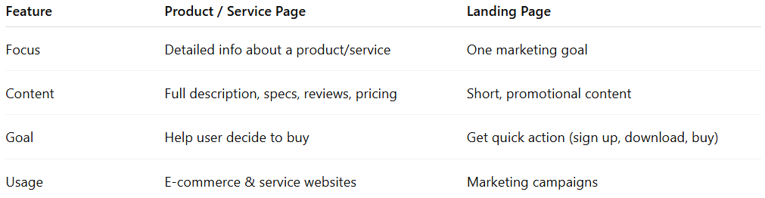
Feature | Product / Service Page | Landing Page
Focus | Detailed info about a product/service | One marketing goal
Content | Full description, specs, reviews, pricing | Short, promotional content
Goal | Help user decide to buy | Get quick action (sign up, download, buy)
Usage | E-commerce & service websites | Marketing campaigns

